**Linux command 11-01-2023**

**#1 man**

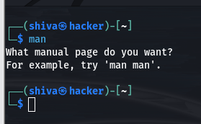

The first command I want to introduce is a command that will help you understand all the other commands. Every time I don't know how to use a command, I type man <command> to get the manual:

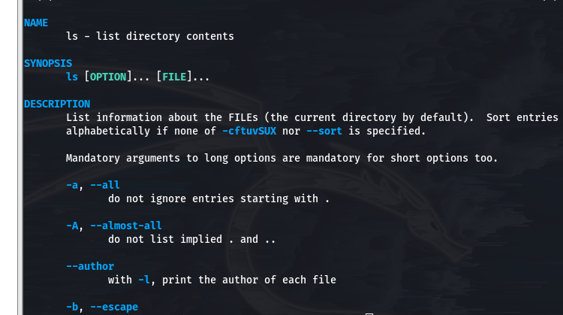

**#2 ls**

* Inside a folder you can list all the files that the folder contains using the ls command:

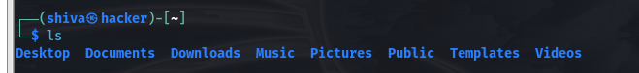

* If you add a folder name or path, it will print that folder contents:
* ls/bin

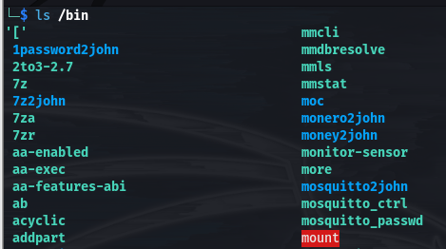

* ls accepts a lot of options. One of my favorite options combinations is - al . Try it:
* **ls -al /bin**

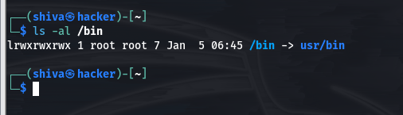

compared to the plain ls , this returns much more information. You have, from left to right:

* the file permissions (and if your system supports ACLs, you get an ACL flag as well)
* the number of links to that file
* the owner of the file
* the group of the file
* the file size in bytes
* the file modified datetime
* the file name

This set of data is generated by the l option. The a option instead also shows the hidden files. Hidden files are files that start with a dot ( . ).

**#3 cd**

Once you have a folder, you can move into it using the cd command. cd means change directory. You invoke it specifying a folder to move into. You can specify a folder name, or an entire path.

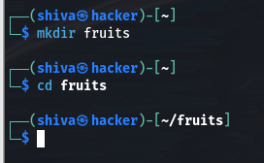

Now you are into the fruits folder

* You can use the .. special path to indicate the parent folder:
* cd .. #back to the home folder
* The # character indicates the start of the comment, which lasts for the entire line after it's found.

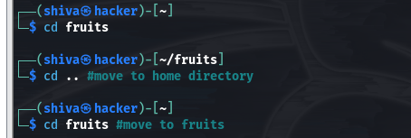

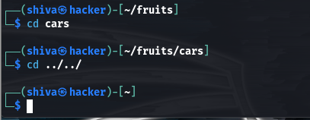

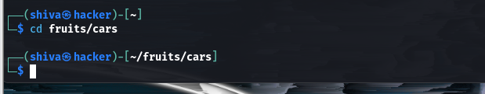

**#4 date**

**#5 mkdir**

* You create folders using the mkdir command:

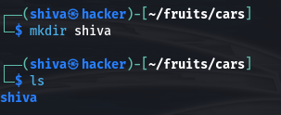

* You can create multiple folders with one command:

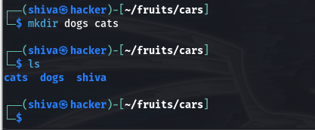

* You can also create multiple nested folders by adding the -p option:

**#6 rmdir**

* Just as you can create a folder using mkdir , you can delete a folder using rmdir:

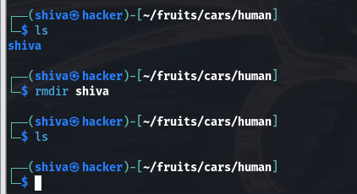

* You can also delete multiple folders at once:

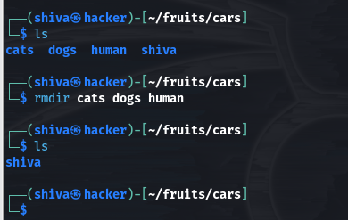

* The folder you delete must be empty:
* To delete folders with files in them, we'll use the more generic rm command which deletes files and folders, using the -rf options:
* Failed if we use rmdir to remove foder which have some content

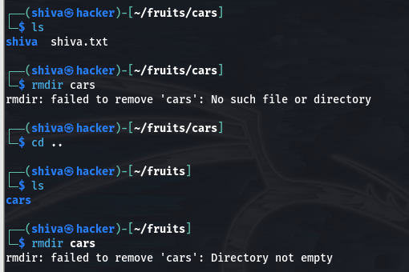

Extended of rmdir:

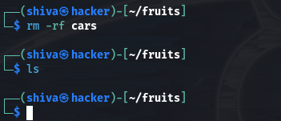

Note: Be careful as this command does not ask for confirmation and it will immediately remove anything you ask it to remove. There is no bin when removing files from the command line, and recovering lost files can be hard.

**#7 touch**

* You can create an empty file using the touch command:

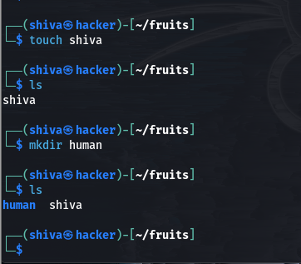

* If the file already exists, it opens the file in write mode, and the timestamp of the file is updated.

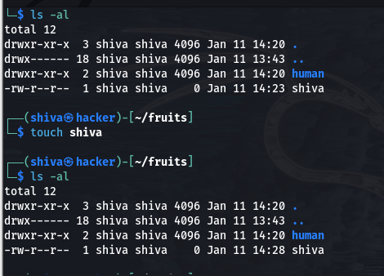

**#7 cat**

Cat(concatenate) command is very frequently used in Linux. It reads data from the file and gives their content as output. It helps us to create, view, concatenate files. So let us see some frequently used cat commands.

* To view a single file : $ cat filename

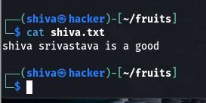

* To view multiple file

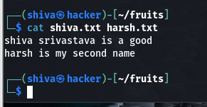

* **To create a file in write mode :** $ cat > newfile

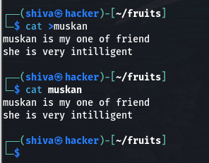

**Note: using > operator we can override previous content**

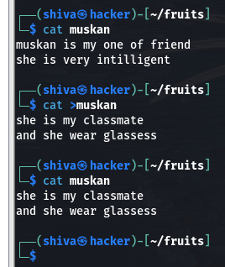

* cat command use in append mode : $cat >> file

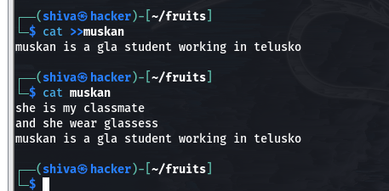

* **Cat command can append the contents of one file to the end of another file.**

